Module 3: Hands-On Lab Guide

# Lab 1 Exercise: From Simplified PRD to Prototype Development

**TASK**: In this hands-on lab, you will use AI to transform the Airbnb SnapWishlist Simplified PRD into a structured prompt pack. Your goal is to master the "translation" step: learning how to break your static requirements into the correct sequence of prompts (Context → Structure → Logic) to build a complex prototype without overwhelming the AI.

### Step 1: Generate Your Prompt Pack Using ChatGPT

In a real workflow, you would copy-paste sections directly from your own Simplified PRD. For this lab, to save time, we have pre-filled the SnapWishlist PRD content into the prompt below. Notice how the prompt inputs map exactly to the 7 Building Blocks you just learned.

**💡 Why use an AI tool like ChatGPT?**

Writing the prompt through ChatGPT ensures that your instructions are complete, consistent with your Simplified PRD, and clearly separated into buildable steps that the tool can understand, without requiring any Lovable credits upfront.

1. Launch [ChatGPT](https://chatgpt.com/) (or any other chatbot you prefer).
2. Copy and paste the meta-prompt below into the chat, run it, and wait for your chatbot to return your prompt pack.

🔁 Want your own version? Before running the prompt, change the city (Kyoto), vibe (Zen, Nature, Historic) and activities (Bamboo Grove, Private Tea Ceremony…..) in the JSON block to something new—e.g., City: “Lisbon, Portugal,” Vibe: “Vibrant, Modern, Fun”, with Activities: “Sunset sailing tour,” “Pastel de Nata tasting,” “Historic tram ride.”

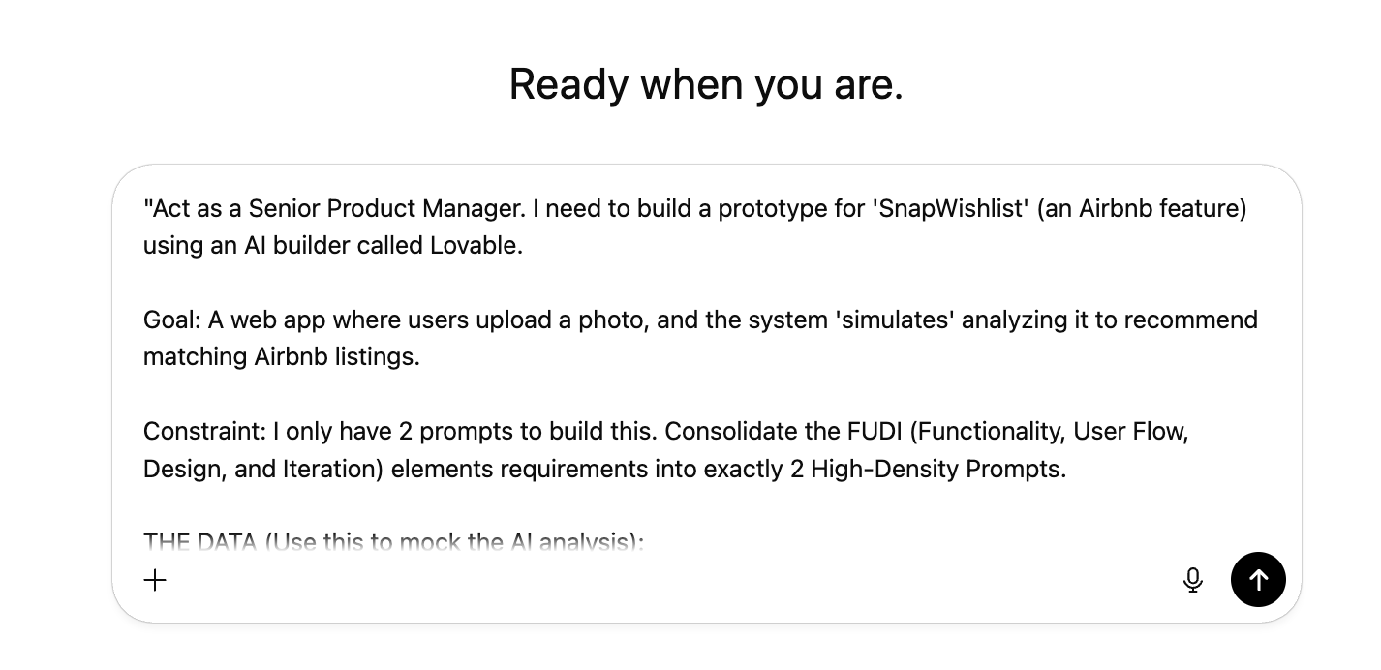

Act as a Senior Product Manager. I need to build a prototype for 'SnapWishlist' (an Airbnb feature) using an AI builder called Lovable.

THE GOAL: Convert my Simplified PRD (pasted below) into a strategic Prompt Pack.

THE CONSTRAINT: I have limited credits. You must consolidate these requirements into exactly 2 High-Density Prompts.

MY SIMPLIFIED PRD CONTENT:

1. Project Overview: Build a web app prototype where users upload inspiration photos, and the system 'simulates' analyzing them to recommend a mix of Airbnb Stays and Experiences.   
Visual style: Airbnb (Clean white, rounded cards, pink accents).

2. Inputs & Outputs (The Mock Data):

Use this JSON list to simulate the AI analysis result:

{ "location": "Kyoto, Japan", "vibe": "Zen, Nature, Historic", "recommendations": [ "Private Garden Ryokan (Entire Home)", "Bamboo Grove Walking Tour (Experience)", "Modern Machiya near Gion (Entire Home)" ] }   
  
3. Ideal User Flow:   
Step 1: Landing Page with 'Upload Photo' dropzone.   
Step 2: 'Scanning...' animation state.   
Step 3: Reveal 'Wishlist Results' (Cards).   
  
4. Results Page Layout: - Display TWO distinct sections, not a single mixed grid.   
- Section 1: Header "Places to Stay" with a home icon, containing only Stay-type cards.   
- Section 2: Header "Experiences" with a compass icon, containing only Experience-type cards.   
- Each section should only appear if it has items.   
  
5. Smart Behaviors (The Logic):   
- Do NOT actually analyze the image.   
- Force the app to display the mocked JSON results regardless of what image is uploaded.   
- Render results as high-fidelity Airbnb cards.   
- Smartly assign a 'Stay' or 'Experience' label, a price, and a Star Rating to each card.   
- The 'Save' heart button must pulse pink on hover.   
  
6. Image Generation Requirement:   
- Use Lovable's AI image generation to create relevant images for each recommendation at BUILD-TIME.   
- Save generated images as static local assets (e.g., src/assets/).   
- Image prompt formula: "[recommendation title] in [location], professional travel photography style"   
- NO runtime AI calls. NO cloud connection required.   
- Images must be fictional scenes, no real people or trademarked locations.   
  
OUTPUT INSTRUCTIONS: Write exactly 2 Prompts in code blocks that I can copy-paste:   
PROMPT 1 (Setup): Cover the Context, Visuals, and Steps 1-2 of the User Flow.   
PROMPT 2 (Logic): Cover the Smart Behaviors, JSON Data, Two-Section Layout, and Image Generation to reveal the Results.   
  
Label the end with '---END PROMPT PACK---'.

1. Check that ChatGPT gave you exactly two prompts. These should align with the outputs in the ​​[EXAMPLE_Simplified PRD.pdf](https://drive.google.com/file/d/1SxkY-MyTBVV7-_3jK5aPFNw9x-zt_-Nf/view?usp=drive_link)

* Prompt 1 (The Setup): Should cover the Project Overview (Context/Visuals) and the first step of the User Flow (The Upload Screen).
* Prompt 2 (The Logic): Should cover the Smart Behaviors (Mock Logic) and Inputs/Outputs (The JSON Results).

### Step 2: Take Your Prompt Pack to Lovable

Now that you’ve generated your consolidated prompt pack in ChatGPT, it’s time to bring your SnapWishlist Simplified PRD to life using Lovable.

1. Open [**Lovable**](https://lovable.dev/) and (if required) sign in to your account.
2. Copy Prompt 1 from your ChatGPT output and paste it into Lovable. Lovable will generate the Landing Page with the Airbnb visual style and the Upload Component.

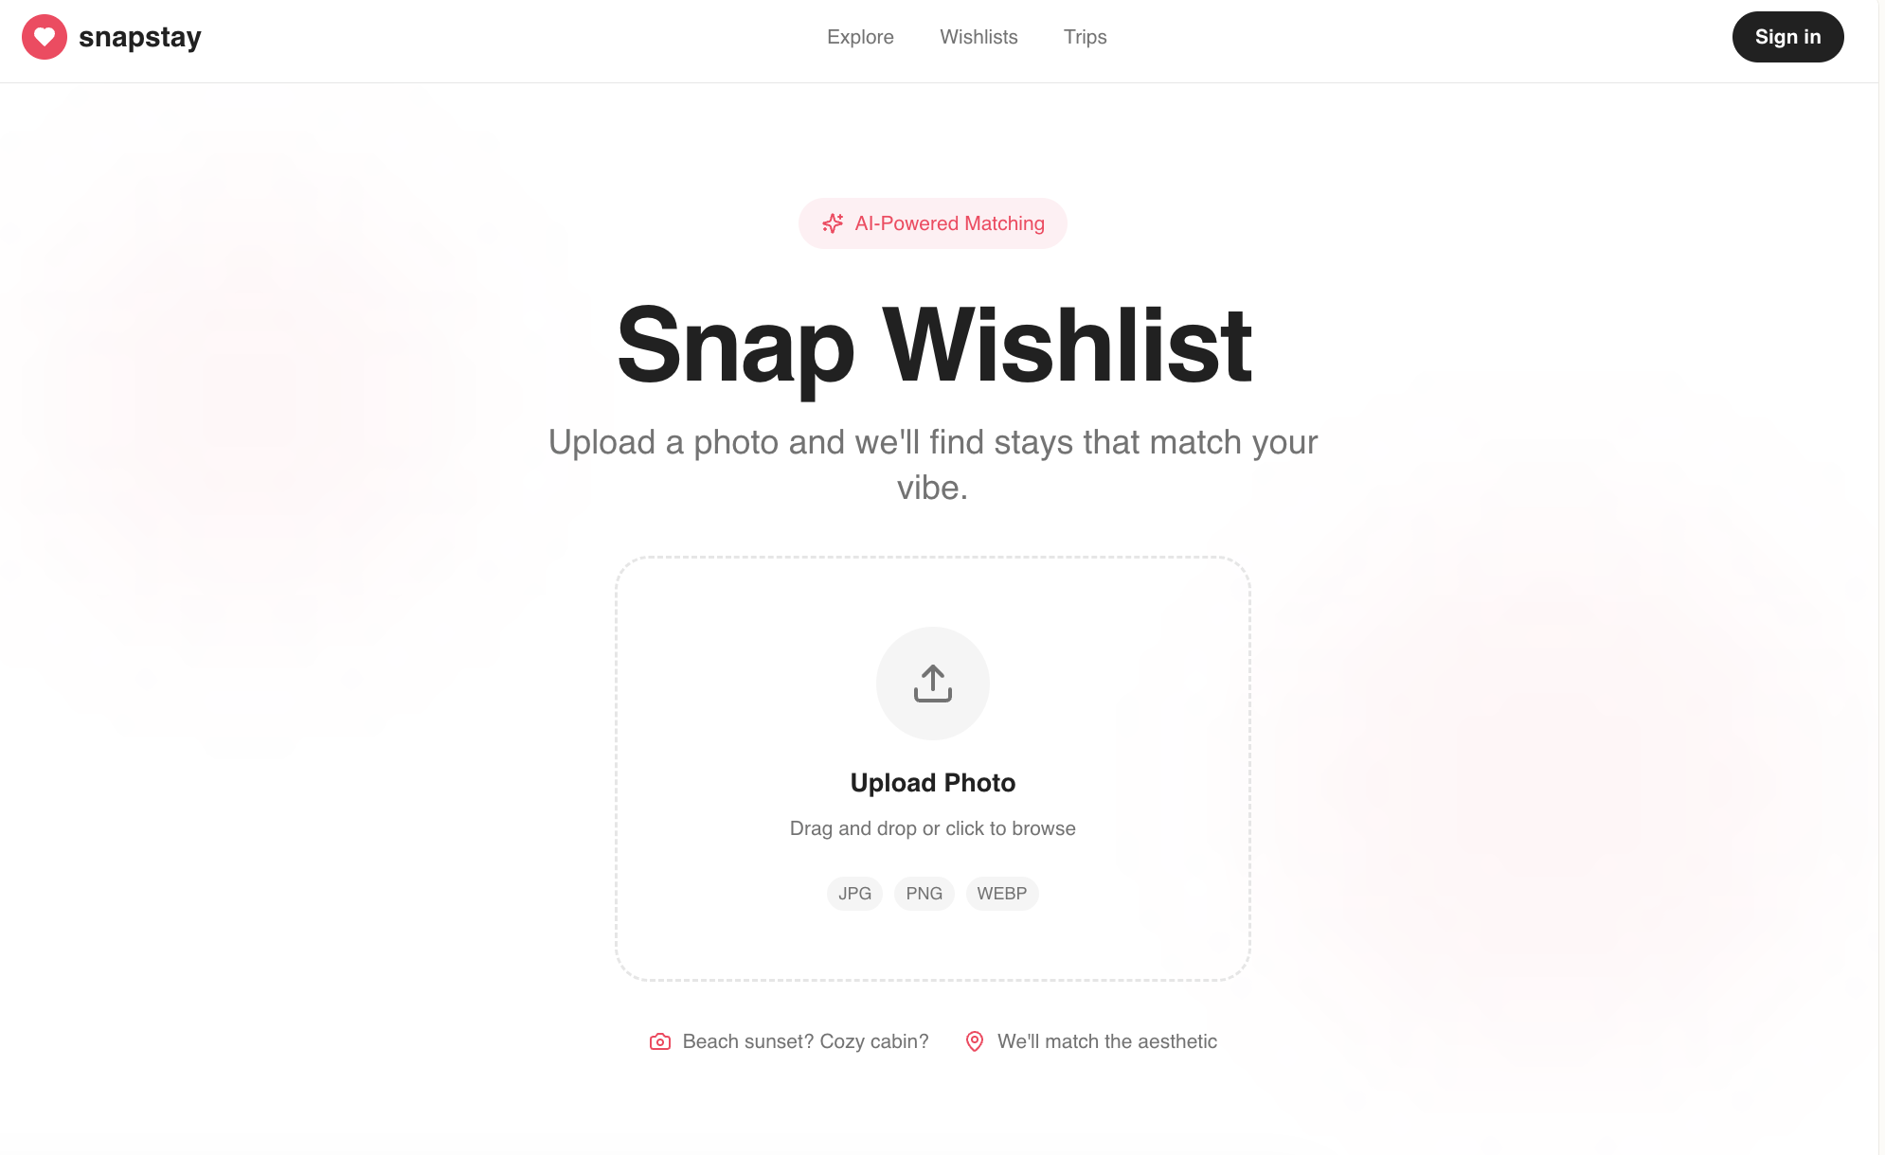

1. Once the preview loads,click the upload button and select any photo from your computer.
   * Note: The upload step is required to trigger the mock “AI analysis,” but Lovable doesn’t actually analyze your image.

If you would like to use the Japan example, download a copy of the photo: [Kyoto_Japan.jpg](https://drive.google.com/file/d/1aLwYZL5A3d6msik5GDTdeUCRrLJnFlsu/view?usp=drive_link)

* + Check: You should see the "Scanning..." animation start. It might get stuck there or show nothing—this is expected because we haven't added the logic yet.

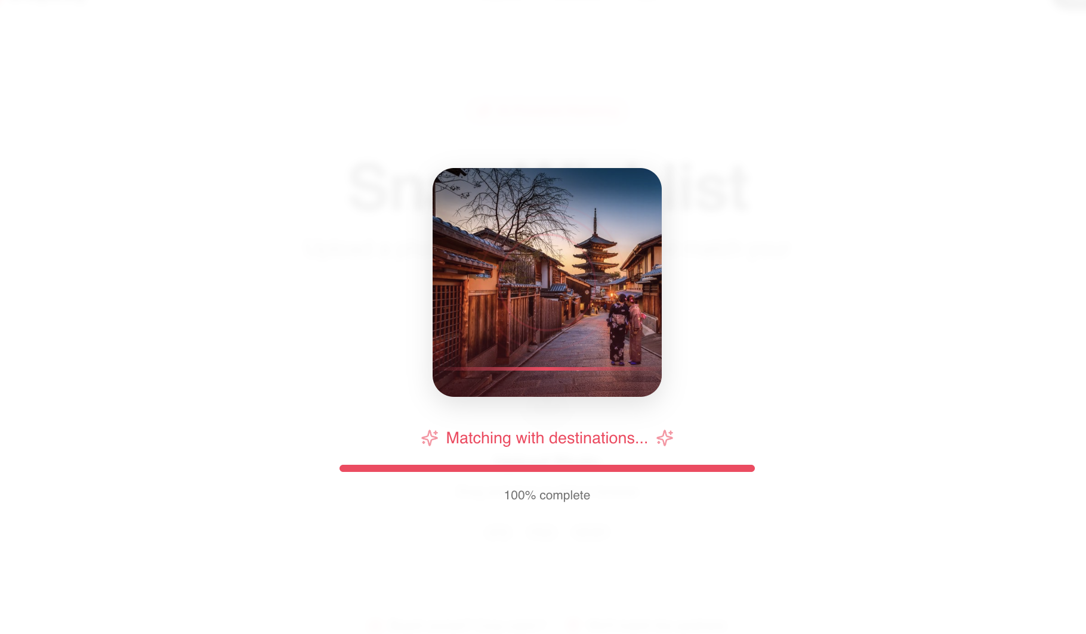

1. Copy Prompt 2 from ChatGPT and paste it into Lovable. This injects the "Smart Behaviors" and the Mock JSON Data. Once finalized, refresh the screen to return to the landing page. Upload your photo again. This time, after the scanning animation, the app will reveal the Result Cards (Stays and Experiences) pulled from your JSON.

Note: If you customized the JSON in Step 1 (e.g., changed "Kyoto" to "Paris"), your prototype will display your custom Paris data here, regardless of which photo you uploaded. This confirms your Simulated Logic is working!

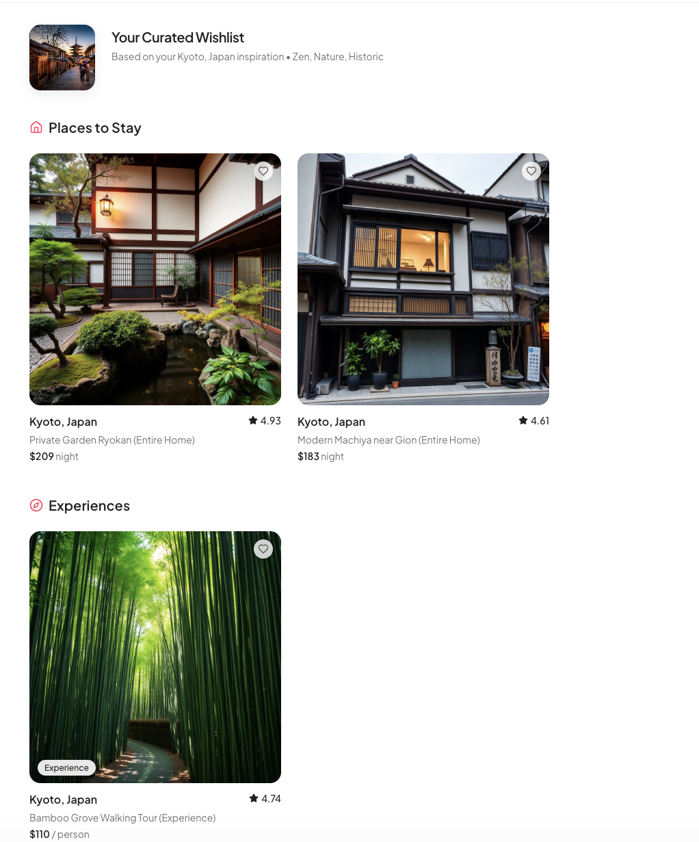

### Step 3: Iterate and Expand

You now have a functional V1 prototype. It works, but are there some pieces that are missing?

1. Look back at the SnapWishlist Simplified PRD example. Are there any critical pieces that are missing?
   1. E.g., The missing Interaction [I] (Success State): When you click the "Heart," what happens? How does the user know it worked?
   2. E.g., The missing User Flow [U] (Detail View): You can see the cards, but you can't click them to see more details.
2. Create your own prompt using ChatGPT, or paste one of the following below directly into Lovable to address one of these key issues.

* Note that for your own prototype workflow, you would then update your Simplified PRD to include these additional requirements, ensuring they are included in your prompt pack.

Example prompts for iteration:

For Option A: "Update the Logic: When I click the heart button, show a small black toast notification at the bottom that says 'Saved to Kyoto Wishlist' for 3 seconds, then fade out."

For Option B: "Update the Interaction: Make the entire card clickable. When clicked, open a centered modal showing the image, title, price, and a dummy description paragraph."

